Current Game Changers Page meta data
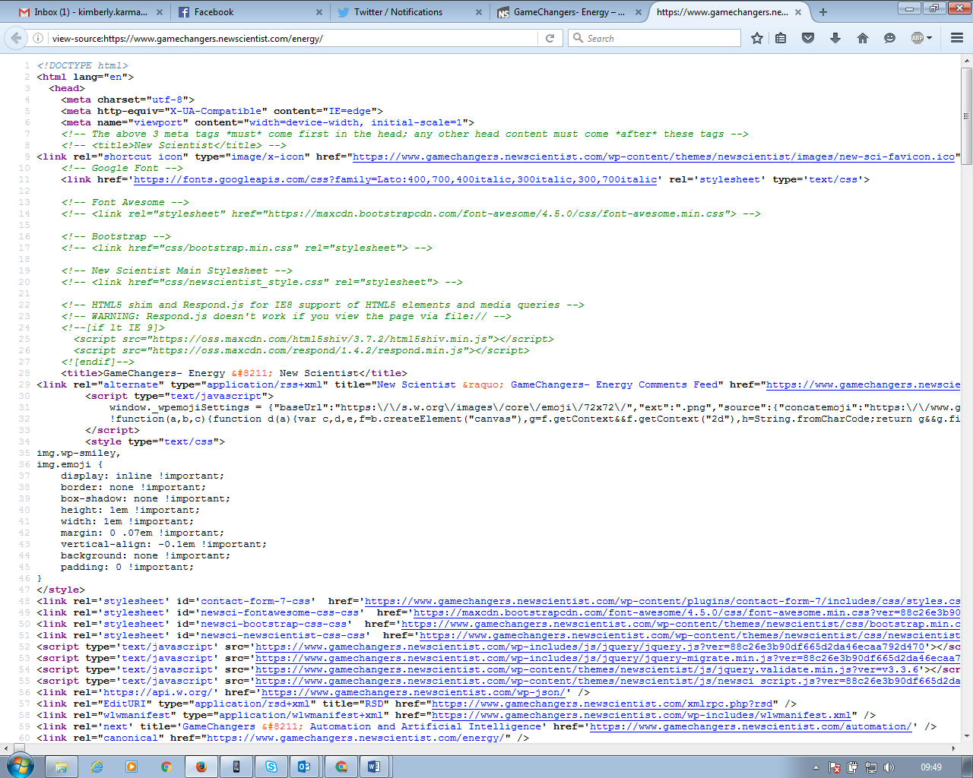
New Scientist Page meta data
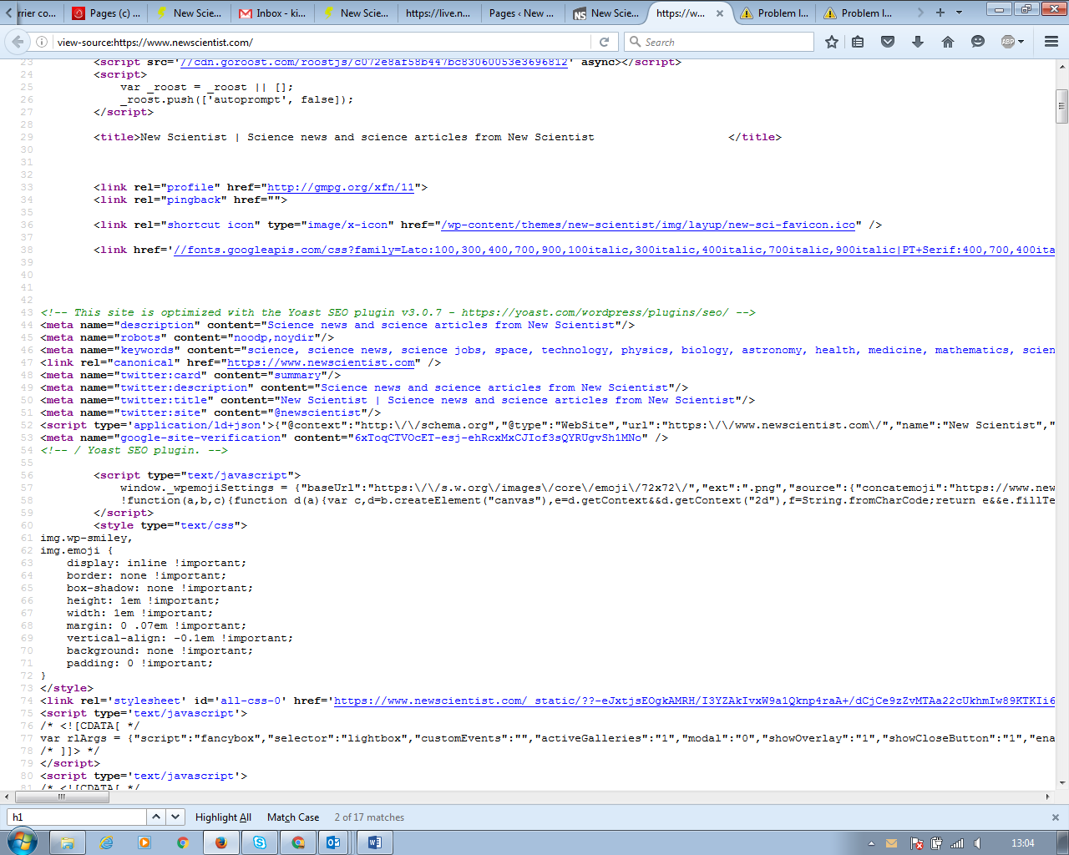

Suggested changes to make:
- Current page title: New Scientist
  - Change page title: New Scientist GameChangers How science and technology will impact the future
- Add h1 tags
- Add description
- Set up Roost module/ add Roost to website
- Add social sharing Twitter description
- Add keywords
- Change page title names for each page
- Create homepage/ landing page

Review of SEO
- Current Search performance 845/11k visits - 7% ; ns.com = 30% - there have been no downloads from organic search as an acquisition source- there is an opportunity to grow search traffic significantly
- Social performance = 7k of 11k visits have come from social – 64% of traffic but from outbound efforts
- Google ranking for benchmark key terms – what terms do you want to rank for?
- Backlink profile
- Competition – who else do we want to compare against?
- Anchor text on page
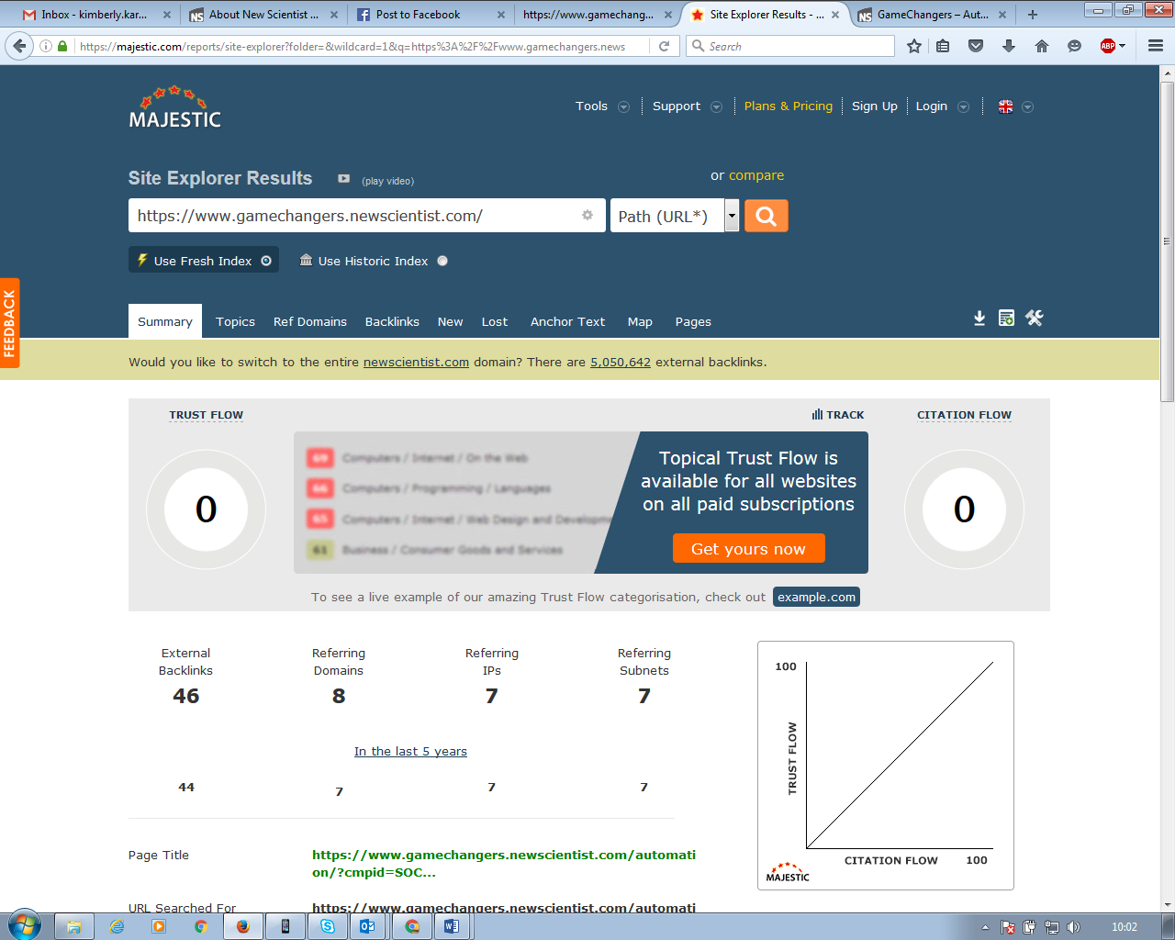
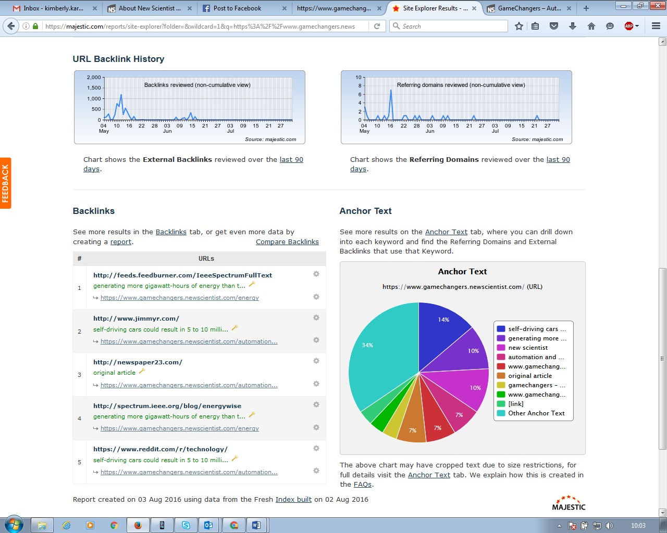

TECHNICAL SEO
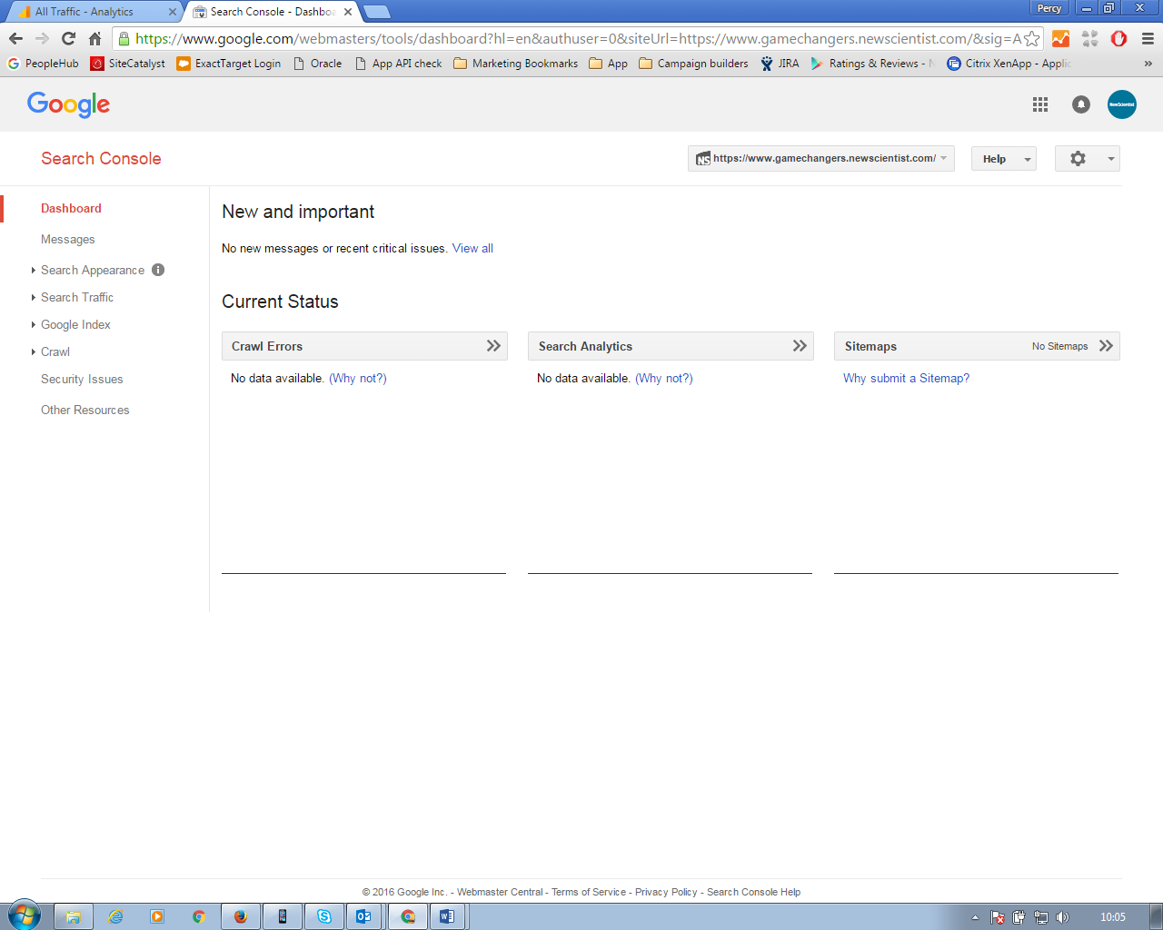
- Not indexed
- Site has not been crawled
- No sitemap has been submitted for robots to crawl
- No structured data
- No rich cards
- Homepage redirect to the latest version Gamechanger article is not good for SEO – redirect on homepage

ON PAGE SEO
- Page Titles – all have the same page title all say “New Scientist”
- Add page page descriptions
- Main page Description
- Header Tags- there is no h1 tagging at all
- Images/ Image tags
- Long tail SEO
- New Scientist Game Changers – separate word will get more results than putting them together
SOCIAL SHARING
- Page title pulling through to socials
- Add share counters on social sharing icons
- Add tracking to indicate how much these functions are being used

